Unit 1 Can you play the guitar?
Ⅰ.读下面的卡片，回答问题
Name Lonadle
Age 13
E-mail Address
Lonadle@hotmail.com
What can you do?
Painting
What club do you want to join?
Art Club
Tel.3089721
Answer the questions:
What's his name?
_______________________
How old is he?
_______________________
What can he do?
_______________________
What club does he want to join?
_______________________
What's his telephone number?
_______________________
Ⅱ.看图补全对话
1)A:Can I help you?
B:____________.I want to join the music club.
A:Can you ____________？
B：No,____________.
A:Can you ____________?
B:Yes,____________.
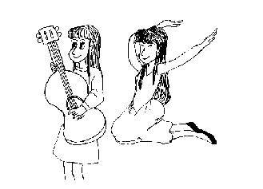
2)Tom ____________,but he ____________.
He wants to ____________ club.

3)Annie ____________,but she ____________.
She wants to ____________ club.
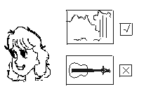
参考答案
Unit 10 Can you play the guitar?
Ⅰ.His name is Lonadle.;He's thirteen.;He can paint.;He wants to join the art club.;His telephone number is 3089721.
Ⅱ.1)Yes;play the violin;I can't;dance;I can
2)can play football,can't play basketball;join the football
3)can draw;can't play the violin;join the art

